10 posts. Additional hashtags will be inserted prior to posting.

**REGIONAL BUSINESS: OFFICE SPACE NEEDED**

**Posted Tuesday, Oct 23 at 2 p.m.**

<http://mykingstonkids.com/home>

MyKingstonKids, an amazing local non-profit organization, is seeking a donated, unfurnished office space in Kingston starting @ November 1 for 6-12 months. Large enough for 3-4 desks. Internet access preferred. Hours of operation: Monday-Friday 9 to 5 or 6 p.m. with 1-2 visitors daily. Contact Frank Waters, Director, at [fwatersonline@yahoo.com](mailto:fwatersonline@yahoo.com) or (945) 282-0182. #MyKingstonKids #UlsterForBusiness

**REGIONAL EVENT, CRAFT FOOD & BEVERAGE SECTOR**

**Posted Tuesday, Oct. 30 at 11:38 a.m.**

So many amazing Ulster County food and beverage makers at the HV Taste NY event today. Love seeing Fruition Chocolate, Tuthilltown, Grok Bites, Nancy's Artisanal and so many more. #UlsterForBusiness #tasteny #TasteFruition #Tuthilltown #GrokBites

**BUSINESS SECTOR: FILMMAKING AND LOCAL JOB OPENING**

**Scheduled for Mon, Oct. 29 at 1 p.m.**

<https://www.stockadeworks.org/jobs/>

Stockade Works in Kingston is seeking a passionate and experienced Program & Administrative Manager. Apply today—don’t miss this exciting opportunity. #UlsterForFilm #StockadeWorks

**SMALL BUSINESS SKILL SETS**

**Scheduled Sun, Nov 4 at noon**

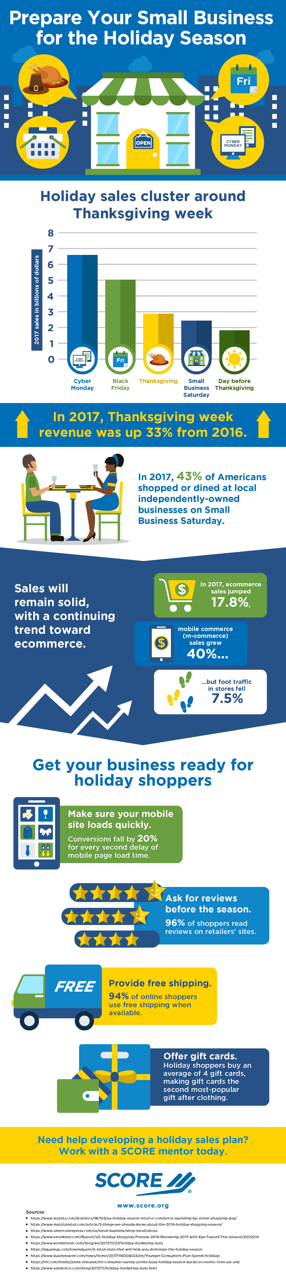

Are you ready for the busy 2018 holiday shopping season? Upswings in e-commerce and mobile sales are predicted, and it all starts during Thanksgiving week. <https://s3.amazonaws.com/mentoring.redesign/s3fs-public/SCORE-infographic-small-business-holiday-prep.pdf> #UlsterForBusiness

**BUSINESS SKILL SETS: NINE VIRTUAL CONFERENCES**

**Scheduled Mon Nov 5 at noon**

<https://onlinexperiences.com/scripts/Server.nxp?LASCmd=AI:4;F:QS!10100&ShowUUID=EF5B1593-A5A3-44E1-8C2E-1F0CF254A2FF&AffiliateData=scorewebsite>

On November 8, nine free educational webinars for small business owners will be live-streamed on topics ranging from credit strategies and hiring hazards to choosing a perfect location and small business loans. If you have business questions, call (845) 340-3556. We can help. #UlsterForBusiness #SCOREMentors

**BUSINESS SKILL SETS: REGIONAL TRAININGS OJT AND WOTC**

**Scheduled Wed, Oct 31 at noon**

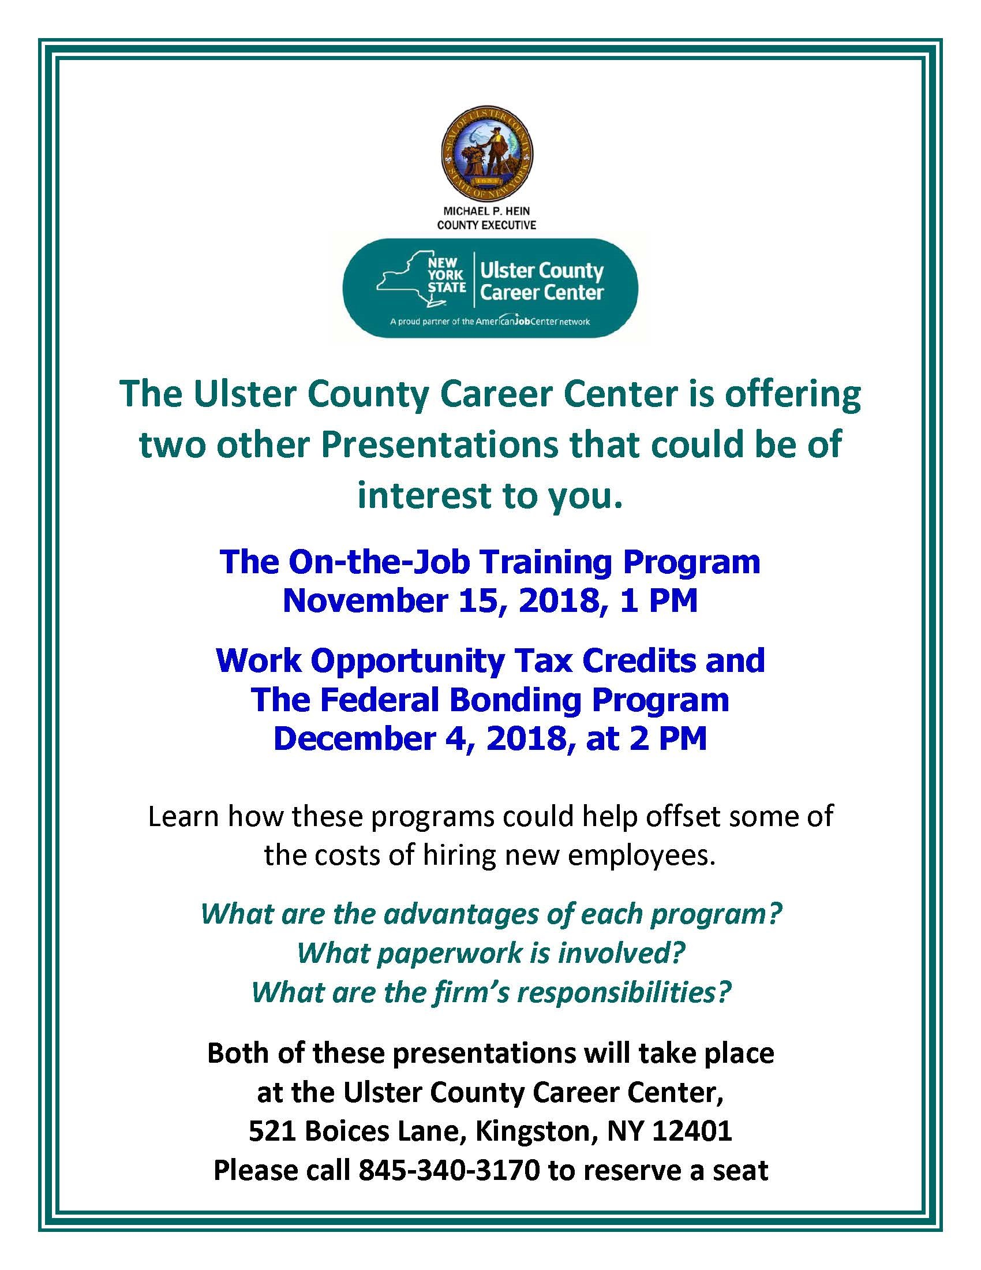

Local businesses! Register today for two free Kingston training programs to help offset the costs of hiring new employees: On-the-Job Training and Work Opportunity Tax Credits/Federal Bonding. Call (845) 340-3170 to reserve your seat. #UlsterForBusiness

**INDUSTRY SECTOR: TECHNOLOGY AND JOB OPENING**

**Scheduled Tues Oct 30 at noon**

<https://apply.interfolio.com/56232>

Opening for Developer for Digital Arts and Humanities at Bard College. Application deadline is November 2. Seeking creative, versatile software developer to design, build and support next-gen applications for projects at interdisciplinary center. #UlsterForBusiness #BardCollege

**INDUSTRY SECTOR: CRAFT FOOD & BEVERAGE, SMALL BUSINESS**

**Scheduled Sat, Nov 3 at noon**



<https://www.valleytable.com/hvrw>

It’s Hudson Valley Restaurant Week—time to make your reservations and try a few restaurants. You’ll find a cornucopia of delicious menus, all celebrating our bountiful harvest season! <https://www.valleytable.com/hvrw> #UlsterForBusiness #tasteny #HVRW #valleytable

**BUSINESS SKILL SETS: FUNDING, LOW INTEREST LOANS IN WOODSTOCK**

**Scheduled Thurs Nov 1 at noon**

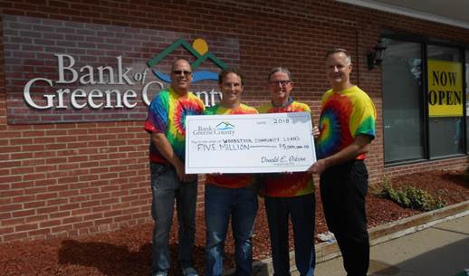

The new Woodstock branch of Bank of Greene County has made a $5 million pledge to community businesses. For more details, please visit <https://www.thebankofgreenecounty.com/business-banking/commercial-lending/>

Call us at (845) 340-3556 if you need help with your application. #UlsterForBusiness

**BUSINESS SKILL SETS: AWARDS COMPETITION**

**Scheduled Fri, Nov 2 at noon**

<https://www.fastcompany.com/apply/world-changing-ideas>

Do you have an innovative product, concept, company, policy or design? *Fast Company’s* “3rd Annual World Changing Ideas” contest includes 17 categories, such as food, AI & data, apps, developing world technology, energy, consumer products and more. Need help with your application entry? Call us at (845) 340-3556. #UlsterForBusiness